**CSC103 LAB 6(STRINGS)**

By:

**UMER FAROOQ (FA22-BCT-036)**

**Submitted to:** SANEEHA AAMIR

**Subject:** PROGRAMMING FUNDAMENTALS

**Date:** 17/4/2023

**DEPARTMENT OF COMPUTER SCIENCE**

**COMSATS UNIVERSITY**

**ISLAMABAD**

# ACTIVITY1:

import java.util.Scanner;

public class activity1{

public static void main(String[] args) {

Scanner input = new Scanner(System.in);

System.out.print("Enter three numbers: ");

double x1 = input.nextDouble();

double y1 = input.nextDouble();

double x2 = input.nextDouble();

double y2 = input.nextDouble();

double x3 = input.nextDouble();

double y3 = input.nextDouble();

double a = Math.sqrt((x2 - x3) * (x2 - x3) + (y2 - y3) * (y2 - y3));

double b = Math.sqrt((x1 - x3) * (x1 - x3) + (y1 - y3) * (y1 - y3));

double c = Math.sqrt((x1 - x2) * (x1 - x2) + (y1 - y2) *(y1 - y2));

double A = Math.toDegrees(Math.acos((a * a - b * b - c * c)/ (-2 * b * c)));

double B = Math.toDegrees(Math.acos((b * b - a * a - c * c)/ (-2 * a * c)));

double C = Math.toDegrees(Math.acos((c * c - b * b - a * a) / (-2 * a * b)));

System.out.println("The three angles are " + Math.round(A * 100) / 100.0 + " " + Math.round(B * 100) / 100.0 + " " + Math.round(C * 100) / 100.0);

input.close();

}

}



# ACTIVITY2:

public class activity2 {

public static void main(String[] args) {

System.out.println("isDigit('a') is " + Character.isDigit('a'));

System.out.println("isLetter('a') is " + Character.isLetter('a'));

System.out.println("isLowerCase('a') is "+ Character.isLowerCase('a'));

System.out.println("isUpperCase('a') is "+ Character.isUpperCase('a'));

System.out.println("toLowerCase('T') is "+ Character.toLowerCase('T'));

System.out.println("toUpperCase('q') is "+ Character.toUpperCase('q')); }

}

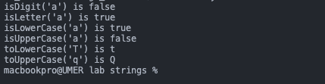

# ACTIVITY3:

import java.util.Scanner;

public class activity3 {

public static void main(String[] args) {

Scanner input = new Scanner(System.in);

System.out.print("Enter the first city: ");

String city1 = input.nextLine();

System.out.print("Enter the second city: ");

String city2 = input.nextLine();

if (city1.compareTo(city2) < 0)

System.out.println("The cities in alphabetical order are " + city1 + " " + city2);

else

System.out.println("The cities in alphabetical order are " +city2 + " " + city1);

input.close();

} }

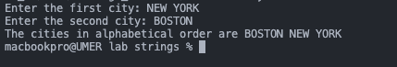

# ACTIVITY4:

public class activity4 {

public static void main(String [] args){

String sentence;

String str1;

String str2;

String str3;

int index;

sentence = "Now is the time for the birthday party";

System.out.println("sentence = \"" + sentence + "\"");

System.out.println("The length of sentence = "+

sentence.length());

System.out.println("The character at index 16 in "+"sentence = " + sentence.charAt(16));

System.out.println("The index of first t in sentence = "+sentence.indexOf('t'));

System.out.println("The index of for in sentence = "+sentence.indexOf("for"));

System.out.println("sentence.substring(0, 6) = \""+

sentence.substring(0, 6) + "\"");

System.out.println("sentence.substring(7, 12) = \""+sentence.substring(7, 12) + "\"");

System.out.println("sentence.substring(7, 22) = \""+sentence.substring(7, 22) + "\"");

System.out.println("sentence.substring(4, 10) = \""+sentence.substring(4, 10) + "\"");

str1 = sentence.substring(0, 8);

System.out.println("str1 = \"" + str1 + "\"");

str2 = sentence.substring(2, 12);

System.out.println("str2 = \"" + str2 + "\"");

System.out.println("sentence in uppercase = \""+ sentence.toUpperCase() + "\"");

index = sentence.indexOf("birthday");

str1 = sentence.substring(index, index + 14);

System.out.println("str1 = \"" + str1 + "\"");

System.out.println("sentence.replace('t', 'T' ) = \""+sentence.replace('t', 'T') + "\"");

}

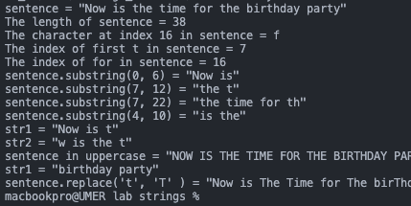

# LAB TASK1:

import java.util.Scanner;

public class labtask1 {

public static void main(String[] args) {

Scanner input = new Scanner(System.in);

System.out.println("Enter point 1 (latitude and longitude) in degrees:");

double x1 = input.nextDouble();

double y1 = input.nextDouble();

System.out.println("Enter point 2 (latitude and longitude) in degrees:");

double x2 = input.nextDouble();

double y2 = input.nextDouble();

double x1_rad = Math.toRadians(x1);

double y1_rad = Math.toRadians(y1);

double x2_rad = Math.toRadians(x2);

double y2_rad = Math.toRadians(y2);

double d = 6371.01 * Math.acos(Math.sin(x1_rad) * Math.sin(x2_rad)

+ Math.cos(x1_rad) * Math.cos(x2_rad) * Math.cos(y1_rad - y2_rad));

System.out.println("The distance between the two points are " + d + " KM");

input.close();

}

}

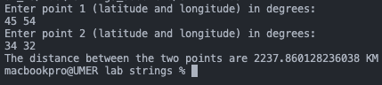

# LAB TASK2:

import java.util.Scanner;

public class labtask2 {

public static void main(String[] args) {

Scanner input = new Scanner(System.in);

System.out.print("Enter an ASCII code: ");

int code = input.nextInt();

if (code < 128) {

char character = (char) code;

System.out.println("The character for ASCII code is " + character);

} else {

System.out.println("You entered wrong input");

}

System.out.print("Enter a character: ");

char character = input.next().charAt(0);

int code2 = (int) character;

System.out.println("The UNICODE for the character is " + code2);

input.close();

}

}

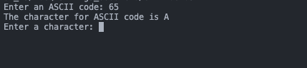

# LAB TASK4:

public class labtask4 {

public static void main(String[] args) {

char alphabet = (char) (65 + Math.random() * 26);

System.out.println("The random uppercase letter is " + alphabet);

}

}





# LAB TASK 6:

import java.util.Scanner;

public class labtask6 {

public static void main(String[] args) {

Scanner input = new Scanner(System.in);

System.out.println("Enter the alphabets: ");

String a1 = input.next();

String a2 = input.next();

System.out.println("The input is " + a1 + " and " + a2);

String temp = "";

temp = a1;

a1 = a2;

a2 = temp;

System.out.println("The output is " + a1 + " and " + a2);

input.close();

}

}

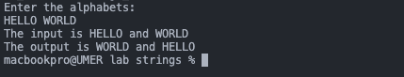

# LAB TASK 7:

import java.util.Scanner;

public class labtask7 {

public static void main(String[] args) {

Scanner input = new Scanner(System.in);

System.out.print("Enter a alphabet: ");

String alphabet = input.next();

for (int i = 0; i < alphabet.length(); i++) {

char alpha = alphabet.charAt(i);

if (alpha == 'f')

System.out.print(i);

}

input.close();

}

}



# LAB TASK 8:

import java.util.Scanner;

public class labtask8 {

public static void main(String[] args) {

Scanner input = new Scanner(System.in);

System.out.println("Enter a line in which H comes twice or more!!! ");

String alphabet = input.nextLine();

int firstIndex = alphabet.indexOf('h');

int lastIndex = alphabet.lastIndexOf('h');

String remaString = alphabet.substring(0, firstIndex) + alphabet.substring(lastIndex);

System.out.println(remaString);

input.close();

}

}

# 

# LAB TASK 9:

import java.util.Scanner;

public class labtask9 {

public static void main(String[] args) {

Scanner input = new Scanner(System.in);

System.out.println("Enter a line in which H comes twice or more!!! ");

String alphabet = input.nextLine();

System.out.println(alphabet.replace('h', 'H'));

input.close();

}

}

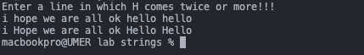

# LAB TASK 10:

public class labtask10 {

public static void main(String[] args) {

String str = "Hello World!";

System.out.println(str.charAt(2));

System.out.println(str.charAt(str.length() - 2));

System.out.println(str.substring(0, 5));

System.out.println(str.substring(0, str.length() - 2));

for (int i = 0; i < str.length(); i += 2) {

System.out.print(str.charAt(i));

}

System.out.println();

for (int i = 1; i < str.length(); i += 2) {

System.out.print(str.charAt(i));

}

System.out.println();

for (int i = str.length() - 1; i >= 0; i--) {

System.out.print(str.charAt(i));

}

System.out.println();

for (int i = str.length() - 1; i >= 0; i -= 2) {

System.out.print(str.charAt(i));

}

System.out.println();

System.out.println(str.length());

}

